IRIS AM software features - Current capabilities:

- Measure temperature of scene – min, mean and max temperature displayed
- Markers highlighting max and minimum temperature
- Changeable colour map
- Temperatures acquired via either power curve fitting (IRIS method) or from look up table (Callum’s method) calibration method
- 1 box ROI with average temperature within box displayed
- Record TIFs and AVI video

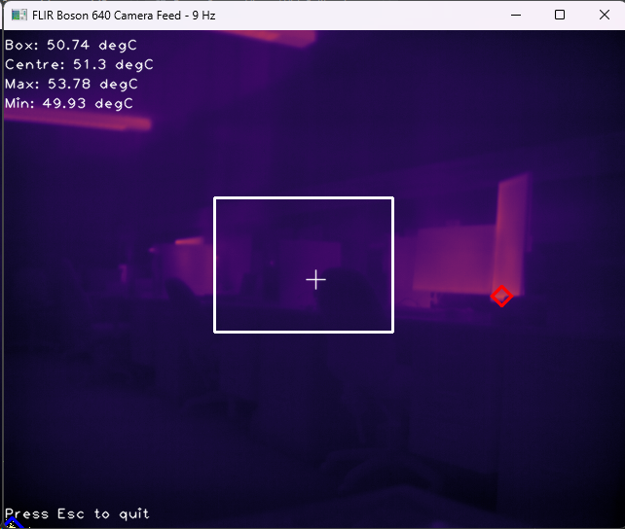
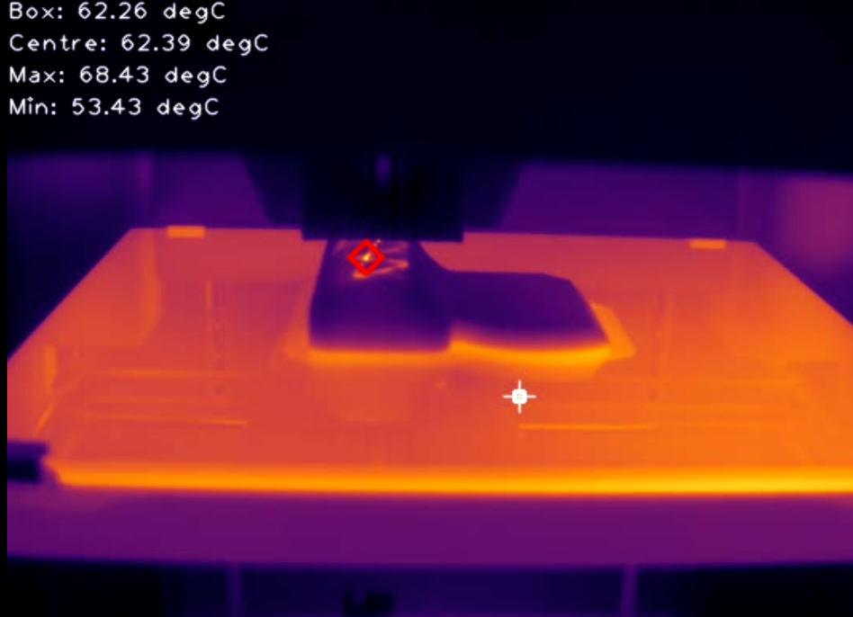

IRIS AM software features - To implement:

- 2 versions of isotherm:
  - 2 slope normalization – set temperature range of interest, allow more “colour resolution” in one part of the temperature range
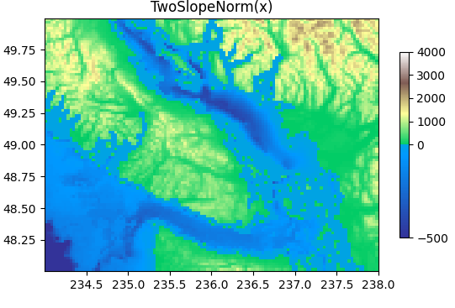
  - True “isotherm” – paint pixels in temperature range of interest one colour

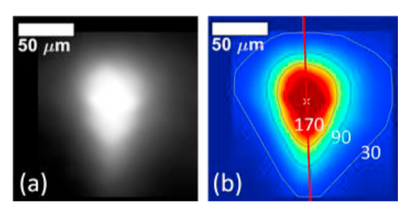

- Add ROIs/lines/points (multiple) – separate temperature indicator for image and ROI

- Temperature image histogram – also definable in ROI/line
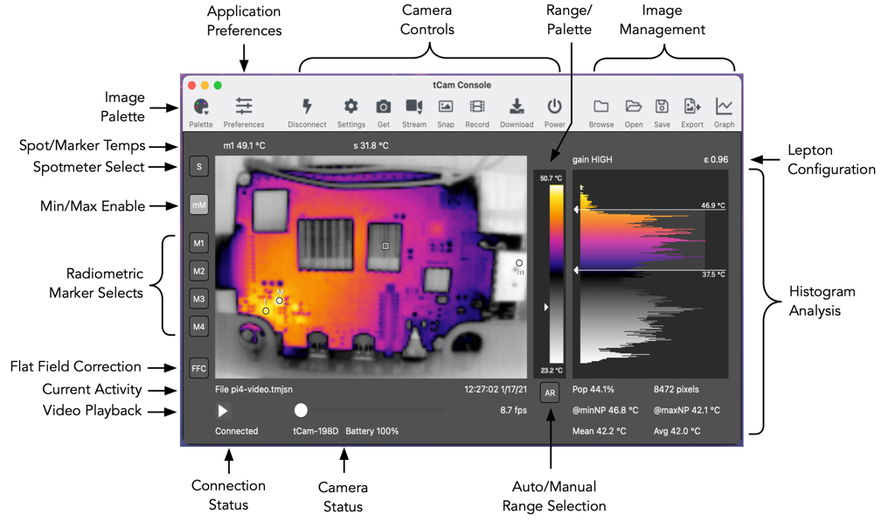
- Temperature alerts for ROIs
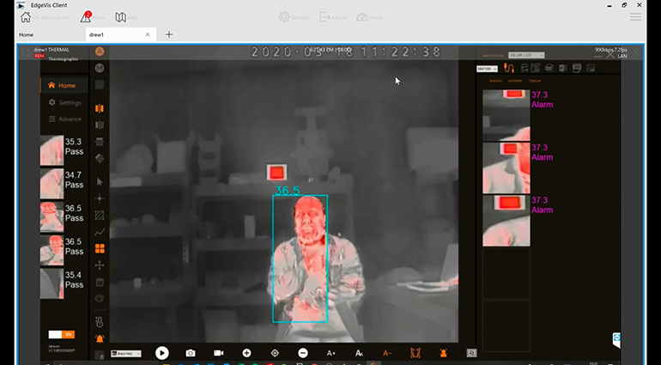

- Emissivity changeable – ROI specific?
- Tracking temperature of ROI over time – time series output

